Spider Report
Cashel McKenna
6th May 2020

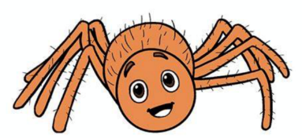

Species:

Spiders are arachnids, a class of arthropods that also includes scorpions, mites, and ticks. There are more than 45,000 known species of spiders, found in habitats all over the world. There’s a spider with a cartoonish bottom, spiders that can jump on demand, and cannibal spiders that look like pelicans. The different species are black widow spider, Orb-Weaver Spider, Daddy Long Legs, Giant House Spider, Lace Web Spider and a lot more.
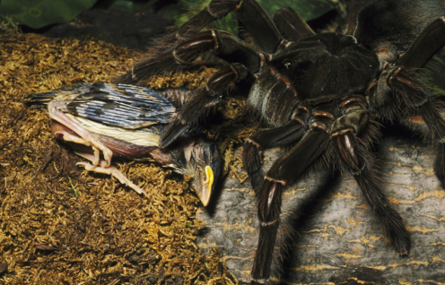
Goliath Bird eater is 12 Inches long. It is the world's largest spider, weighing in around 175 g. It is a type of tarantula. The spider can bite and sometimes delivers a venom comparable to that of a wasp sting. Its barbed hairs present a greater threat, as they can lodge in the skin and eyes, producing itching and irritation for days.
This spider sometimes eats birds. However, it's probably more afraid of you than you are of it, since humans who live in its habitat catch it and cook it (tastes like shrimp).
Where It Lives: In burrows in the rainforests and swamps of northern South America. If you like, you can keep one as a pet (but I wouldn’t want to)…
Habitat:
Spiders live in almost every habitat on earth. The only places where there are no spiders are the polar regions, the highest mountains and the oceans. A few spider species have invaded the ocean's edge, living in the rock and coral crevices.
Fun facts:
- Many spiders have four pairs of eyes.
- Tarantulas are one of the heaviest and largest spiders in the world. They can be as long as 90 mm with a legspan of 250 mm.
- Patu digua is the smallest spider in the world with the length measuring only 0.37 mm. It lives in Columbia.
- Unlike tarantulas having a lifespan of 20 years, almost all spiders live no more than 2 – 3 years.

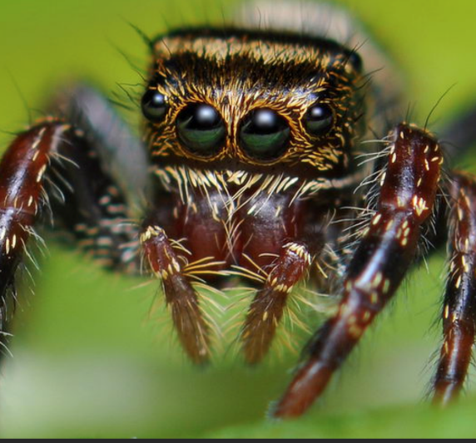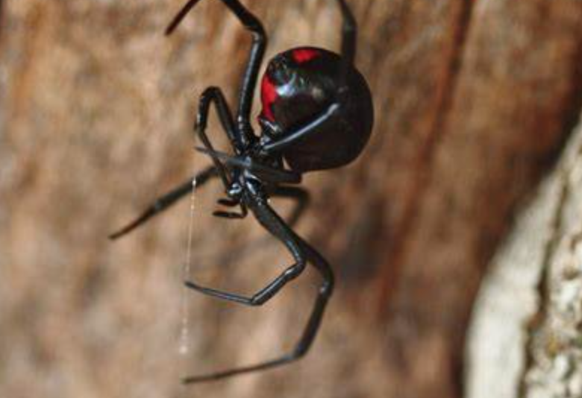
DEADLIEST SPIDERS
The deadliest spiders are…
- Brazilian Wandering Spider
- Black Widow Spider
- Hobo Spider
- Fringed Ornamental Tarantula
- Six-Eyed Sand Spider
- Wolf Spider
- Yellow Sac Spider
- Brown Recluse Spider
- Mouse Spider
- Red Widow Spider

Spiders have many different methods of capturing prey. The most common one that occurs with the majority of species has to do with them creating a web. It is silky and it is sticky so anything that gets into it will be trapped there. Almost all known spider species are predators, mostly preying on insects and on other spiders, although a few species also take vertebrates such as frogs, lizards, fish, and even birds and bats. Spiders' guts are too narrow to take solids, and they liquidize their food by flooding it with digestive enzymes.
Though most spiders are almost exclusively carnivorous, a few species, primarily of jumping spiders, supplement their diet with plant matter such as sap, nectar, and pollen. However, most of these spiders still need a mostly carnivorous diet to survive, and lab studies have shown that they become unhealthy when fed only plants.

Webs
Every web begins with a single thread, which forms the basis of the rest of the structure. To establish this bridge, the spider climbs to a suitable starting point (up a tree branch, for example) and releases a length of thread into the wind. With any luck, the free end of the thread will catch onto another branch. If the spider feels that the thread has caught onto something, it cinches up the silk and attaches the thread to the starting point.
It walks across the thread, releasing a looser thread below the first one. It attaches this thread on both ends and climbs to its centre. The looser strand sags downward, forming a V-shape. The spider lowers itself from this point, to form a Y-shape. This forms the core support structure of the web.
The spider easily grips the thin threads with special serrated claws, a smooth hook and a series of barbed hairs on the end of its legs. As it walks along the initial structural threads, it lays more frame threads between various anchor points. Then it starts laying out radius threads from the centre of the web to the frames. The spider does not coat the frame and radius threads with sticky material, since it needs to walk across them to get around the web.
After building all the radius threads, the spider lays more non-stick silk to form an auxiliary spiral, extending from the centre of the web to the outer edge of the web. The spider then spirals in on the web, laying out sticky thread and using the auxiliary spiral as a reference. The spider eats up the auxiliary spiral as it lays out the sticky spiral, resulting in a web with non-sticky radius threads, for getting around, and a sticky spiral for catching bugs.
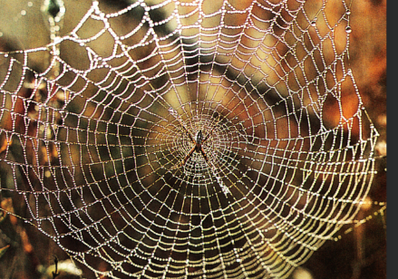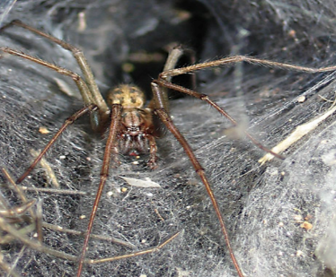

Words to know
Abdomen – the back part of a spider’s body, where the spinneret glands are
Arachnid – the class that spiders are in (not all spiders are arachnids)
Cephalothorax – the front part of a spider’s body, where their head and eyes are
Exoskeleton – a skeleton that is outside a body instead of inside (which is called an endoskeleton)
Sac – the round ball that spider mums make to hold their eggs in
Spinnerets – the glands that produce silk for spinning webs, catching prey and protecting eggs

Did you know?
- In the UK, there has never been a recorded death from a spider bite.
- It takes a spider about an hour to build a web, and they usually build a new one every day.
- Not all spiders catch their food in webs. For instance, the wolf spider makes a hole in the ground, and waits inside for prey to come near before catching them.
- The largest spiders are tarantulas, and the largest tarantula is the Goliath tarantula.
- The smallest spider in the world is the Patu marplesi, and it was found in Samoa (in the South Pacific Ocean).
- Even though spiders have eight eyes, most of them can’t see very well – they rely on what they feel in order to know when they’ve caught prey in their webs.
- The average human adult is over a 250,000 times heavier than a spider by weight!
- Most spiders that build webs are called orb-weaver spiders – this is because the web is a round spiral.
- Not all webs are made in the spiral shape that we see most often. Some spiders build webs in tube shapes, funnel shapes, or in dense sheets.
- Being afraid of spiders is called arachnophobia (a ‘phobia’ is a fear). It’s the most common fear that people have, but spiders shouldn’t be so scary. In the UK, nobody has ever died because they were bitten by a spider.
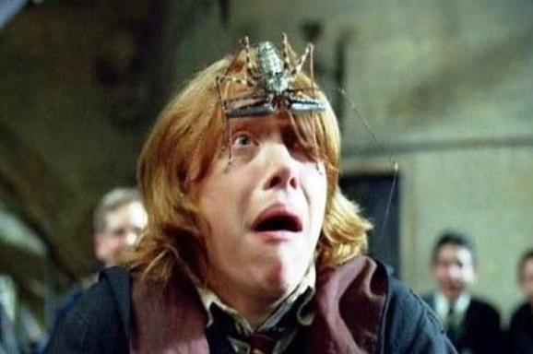

The End…

