BEE REPORT

Cashel McKenna
2nd May 2020

Introduction
There are many different type’s of bees: bumble bees, carpenter bees, honey bees and killer bees.
Bees are endangered because bears are destroying their hives, birds eat them and so do small mammals. However the biggest threat of all is humans and pesticides. But we can help them A LOT by not putting
chemicals on plants, by making a bee bath (a small bowel of water with stone’s in it).

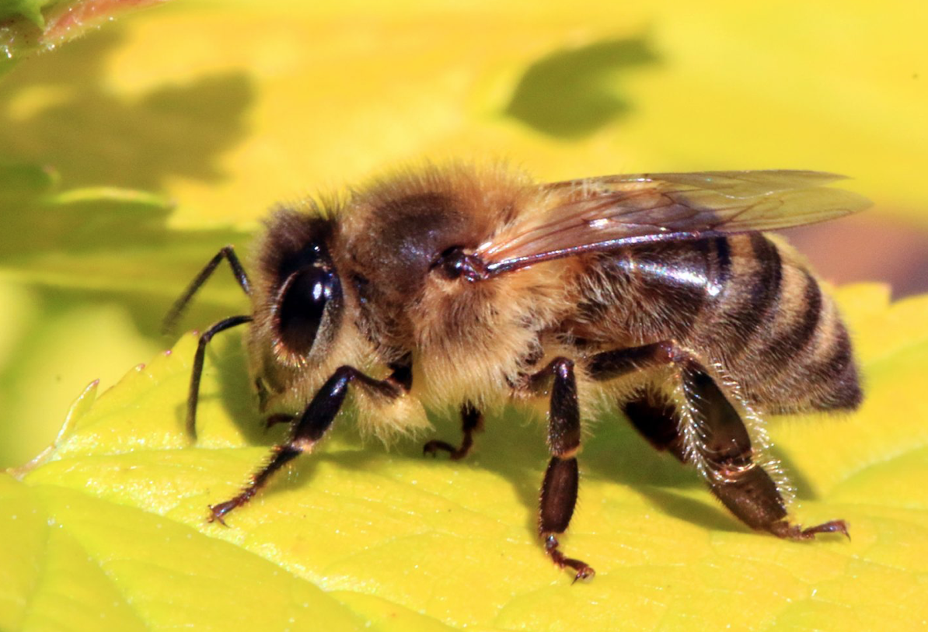

Bee’s have five eye’s. Two main eye’s & three smaller ones.
Bumblebee’s are hairy, black, yellow or orange in colour and up to 25 mm long.

Bee life cycle
First the Queen bee lays an egg in honeycomb. Next the egg hatches into larvae. Then the larvae
eats royal jelly. After that it eats bee bread (Bee bread is not real bread it is a mixture pollen and
honey).
Finally the larvae spins a cocoon and comes out in twenty one day’ as a fully grown bee!
Bee’s live for 5 or 6 weeks but the Queen bee lives for 5 or 6 years!!!!!!!!
If bees all die, we all die.

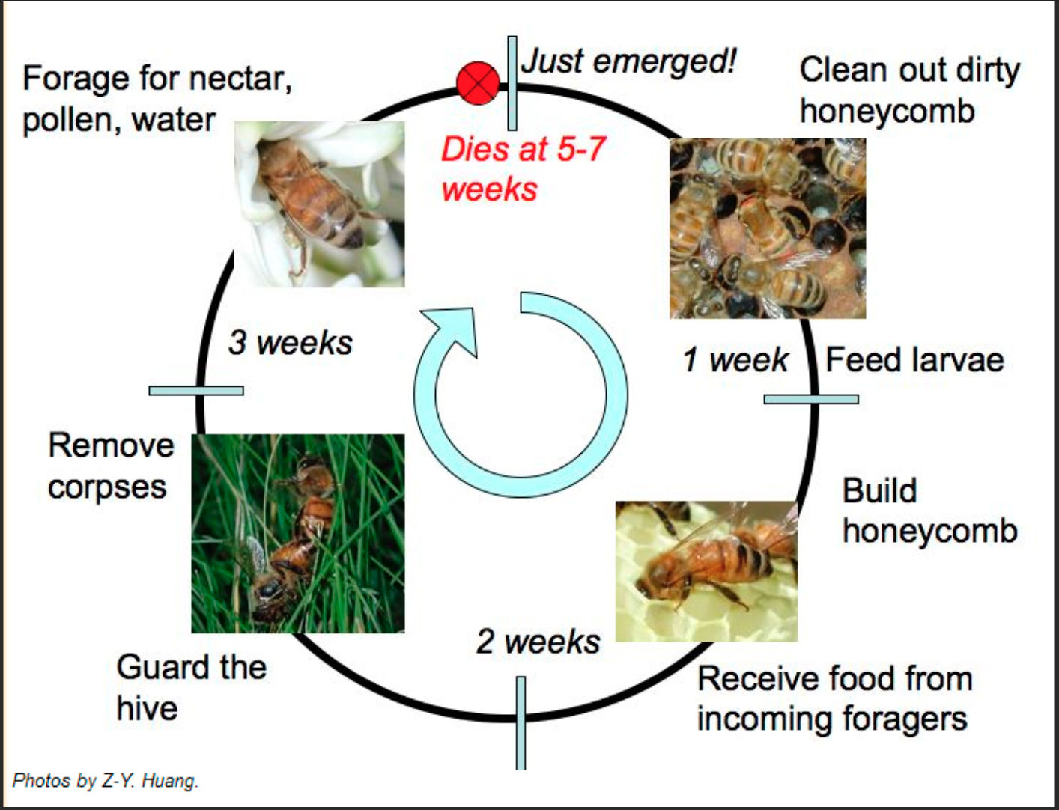

Bee facts
- Beekeepers use smoke to calm bees when they are collecting honey or relocating a hive.
- Bees make honey to feed their young and so they have something to eat during the winter.
- Killer bees have been known to chase people for over a 1/4 mile once they get excited and aggressive.
- Certain species of bees die after stinging because their stingers, which are attached to their abdomen, have little barbs or hooks on them. When this type of bee tries to fly away after stinging something, part of the abdomen is ripped away.

There are about 20,000 different species of bees in the world. Bees live in colonies that contain the queen bee, the worker bee and the drone. The worker bee and the queen bee are both female, but only the queen bee can reproduce. All drones are male. Worker bees clean the hive, collecting pollen and nectar to feed the colony and they take care of the offspring. The drone’s only job is to mate with the queen. The queen’s only job is to lay eggs.

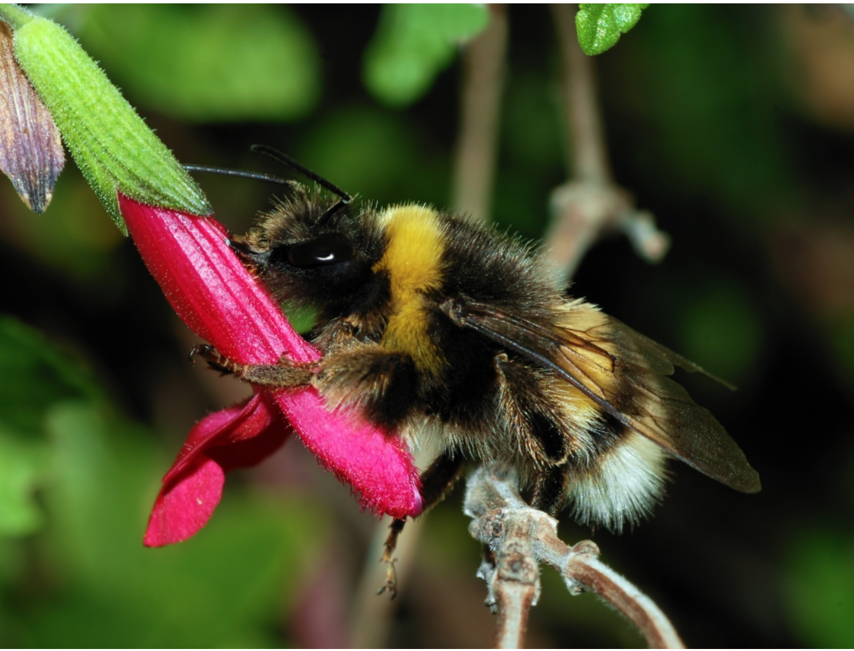

Bees store their venom in a sac attached to their stinger and only female bees sting.
Bees see all colors except the color red. That and their sense of smell help them find the flowers they need to collect pollen. Not only is pollen a food source for bees, but also some of the pollen is dropped in flight, resulting in cross pollination. The relationship between the plant and the insect is called symbiosis.

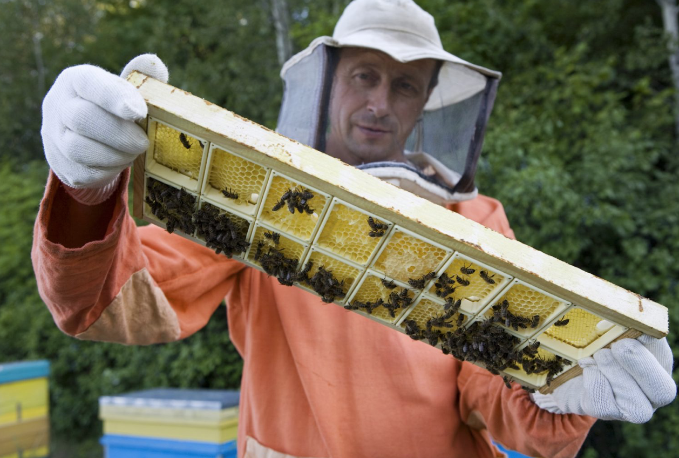

The earliest animal-pollinated flowers were pollinated by insects such as beetles, long before bees first appeared. Bees are different because they are specialized as pollination agents, with behavioral and physical modifications that make pollination easier. Bees are generally better at the task than other pollinating insects such as beetles, flies, butterflies and pollen wasps.

Wasps are not bees. Wasps are less fat and when a wasp stings they don’t die but a bee does.
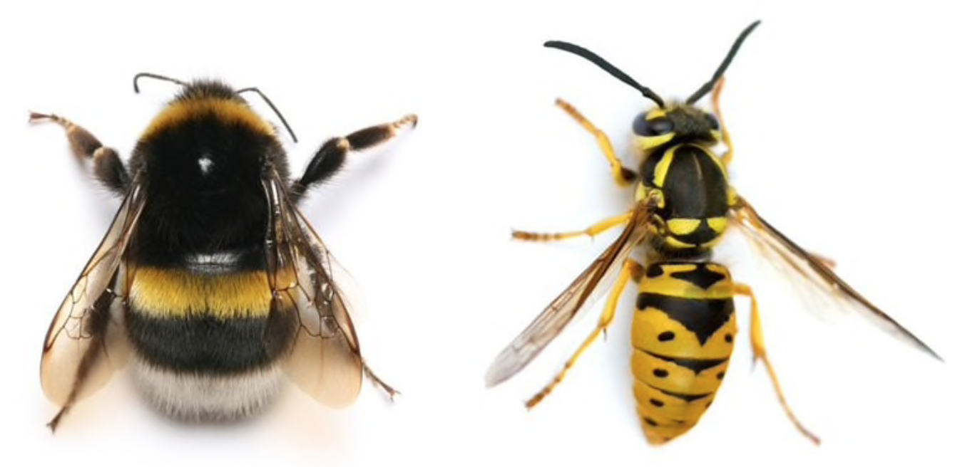

Bumblebees are large, furry, and charismatic four-winged insects that belong to an order called the Hymenoptera, which also includes sawflies, ants, and wasps. They are well-known for their meandering, “bumbling” flight, and their distinctive buzz – which is where their Latin name Bombus (meaning
“booming”) originates.

How can a bee fly
The distance each bee flies in its life is astonishing. It is possible for bees to fly as far as 5 miles for food, however an average distance would be less than a mile from the hive. A strong colony therefore flies the equivalent distance from Earth to the Moon everyday.
The normal top speed of a worker would be about 15-20mph (21-28km/h) when flying to a food source and about 12mph (17km/h) when returning with nectar, pollen, propolis (resin collected from tree buds) or water.
The distance each bee flies in its life is astonishing. It is possible for bees to fly as far as 5 miles for food, however an average distance would be less than a mile from the hive. A strong colony therefore flies the equivalent distance from Earth to the Moon everyday.
The normal top speed of a worker would be about 15-20mph (21-28km/h) when flying to a food source and about 12mph (17km/h) when returning with nectar, pollen, propolis (resin collected from tree buds) or water.

