Guide for Parents

In order to join Class Dojo, you will need to download a QR Reader (free to download). Scan the QR code provided and this will bring you to your child’s account. Have fun navigating the App and look out for messages from your child’s class teacher.
If you have difficulty accessing the App using the QR code, please email the school info account info@stbrides.belfast.ni.sch.uk and someone will send you a link via email.

When you are logged on:
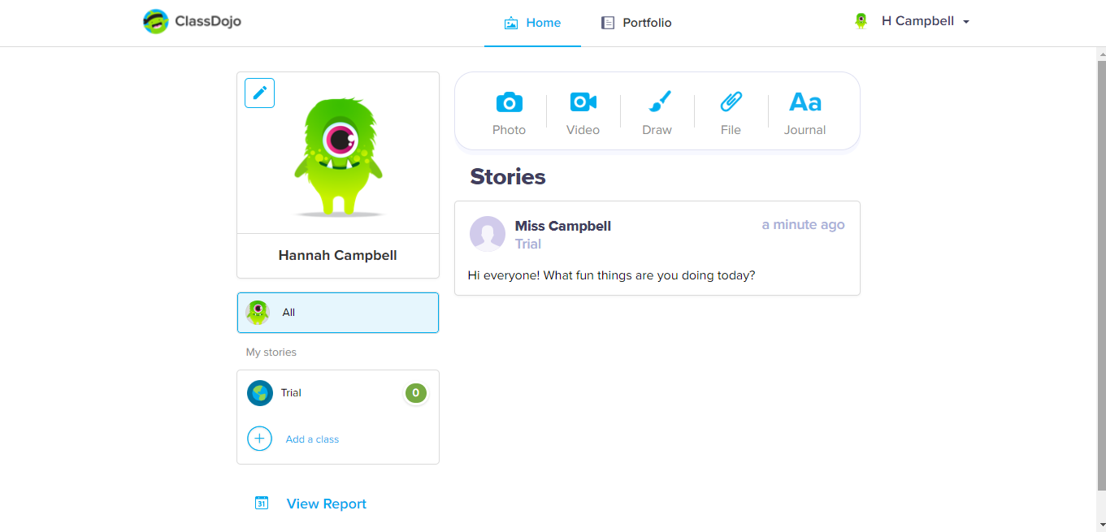
- This is what your child’s page will look like.
- As you can see at the top there are two sections, home and stories.
- ‘Home’ is where the whole class can see what is posted and will be primarily used for the teacher to write to the children, as seen above.

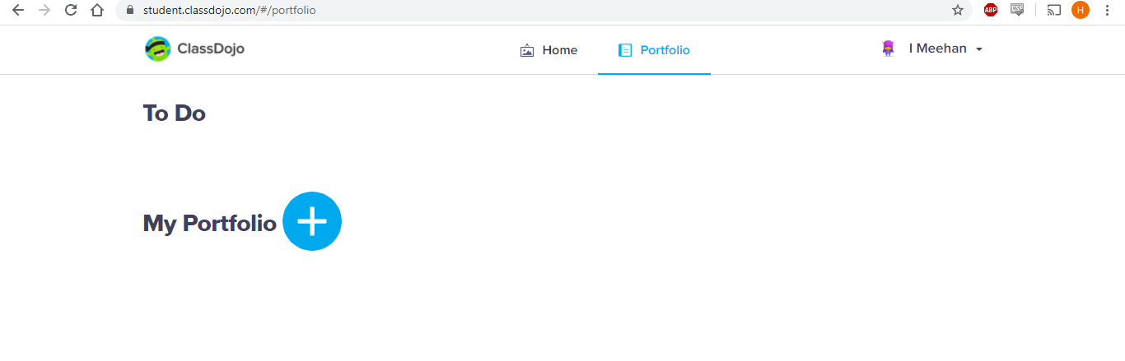
This is your portfolio, click the plus to add photos, videos, text etc. Only you and the teacher can see this. If parents have queries they can use the text button to write it in here.

We hope this helps and please be patient with us- it could take a while to iron out any problems!

Thank you and take care,
Years 1 – 3 Teachers

