    6th April 2020

Dear Parents,

We hope you have found the home learning pack useful. You may now be looking for more work/ideas to do with your child. This document covers Holy Week. The next set of Home Learning will be posted on the 20th April and then every fortnight. Any resources needed will be at the end of the document. You do not need to print these, you can easily just jot them down on a piece of paper. Additional links to helpful websites and ideas will be posted at the bottoms of this document. These tasks are for guidance only- the health and wellbeing of you and your family is a priority. Do what is right for you.

Keep safe,

P2 Teachers

Monday 6th April- Thursday 9th April

Daily revision and information

* Days of the week, months of the year, count forwards and backwards to 30.
* Do 10 add and 10 takeaway sums within 20.
* Read for 15 minutes aloud to an adult and 15 minutes alone.
* Go over your phonic alphabet and the P2 sounds (flashcards with resources at bottom of document)
* Keep a diary, with 2 stars and a wish. I.e. 2 good things that happened and 1 thing that you wish could improve. E.g. My good things were yummy pancakes for breakfast, going for a walk with a torch. I wish I hadn’t dropped the glass and broke it.
* Write and learn spellings each day (find spellings in phonics section) - **if your child usually only does five spellings please pick five from the list of ten for them to write and learn**.
* After explanations examples may be given. These are to be used as guidance for the adult and not for the children to copy.

Writing 

* Ask an adult to tell you the story of Holy Week- you could look in the Bible or use the sample below. Now draw 4 pictures showing what happened on Palm Sunday, Holy Thursday, Good Friday and Easter Sunday. Use the time words First, Next, Then, Finally and the words in the word-bank to retell the story.

|  |  |  |  |  |
| --- | --- | --- | --- | --- |
| Jesus | disciples | tomb | friends | carry |
| bread | palms | donkey | supper | Easter |

|  |
| --- |
| Holy Week Sample  Jesus lived an important life. One week was very special. First on Palm Sunday he rode into Jerusalem on a donkey. Everyone was very happy to see him and waved palms. Next on Holy Thursday Jesus had a special meal with his disciples called the Last Supper. They shared bread and wine. After that on Good Friday Jesus had to carry a heavy cross up a hill. He died on the cross. Finally, on Easter Sunday his friends went to the tomb. The stone had moved. Jesus was alive. It was the first Easter.  *Please note, some children may be able to write more detail, but others may just write one sentence for each day of Holy Week.* |

Talking and Listening

* Talk about what happened during Holy Week with an adult before you write your story. This will help you when you are writing it.

Phonics/Spellings

* ee/oo- sometimes when two letters are together, they make a new sound. Two e’s together say ee like feet. Two o’s together say oo like moon. Can you make a list of five more ee and five more oo words?

Did you think of any of these words? Now write some of these words in a sentence.

|  |  |  |  |  |
| --- | --- | --- | --- | --- |
| green | sleep | meet | creep | three |
| moon | spoon | broom | room | soon |

Reading 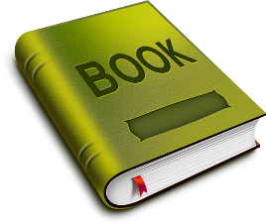

* Read a book of your choice and complete ‘same and different’ activity.

Choose 2 characters. Draw each character and write 4 words to describe them. Now write 3 sentences about each character. Write 3 things the same and 3 things that are different about the character.

Sample

|  |  |
| --- | --- |
| ***Jack*** | ***Giant*** |
| *boy* | *huge* |
| *brave* | *angry* |
| *blonde* | *fierce* |
| *worried* | *greedy* |

*e.g. Jack is a boy. He is brave. He has blonde hair. He was worried about his mum.*

|  |  |
| --- | --- |
| ***Same*** | ***Different*** |
| *Both male* | *The giant was bigger* |
| *Both climbed a beanstalk* | *The giant had more money* |
| *Both wanted the hen* | *Jack was nicer* |

Numeracy

* Heinemann Data Workbook page 3 and 4. Remember to label your graph and start colouring from the bottom.
* Find ten items in your kitchen cupboards. Sort these into heavy and light. Choose two items and compare e.g. the beans are heavier than the crisps. Try this a few times.
* Write the time one hour **after** these times:
  + half past 2, 4 o’clock, 6 o’clock, 12 o’clock, half past 8
* Write the time one hour **before** these times:
  + 5 o’clock, half past 3, 1 o’clock, 10 o’clock, half past 7

WAU

* Our new topic is materials. Find, draw and label things made from wood, plastic and metal.
* Can you find things made from more than one material? What are they made from?

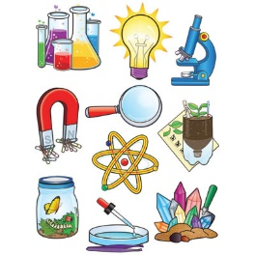

Outdoor Learning

* Collect some sticks, stones and leaves. Make a picture, ask someone else what it is. Ask them to make a picture, can you guess what it is? Try drawing the picture you made with crayons or markers.

Creative arts 

* Sing some of the songs we have learnt this year e.g. See the Light.
* Look in the recycling. Can you make a musical instrument and use them to keep the beat to See the Light? Ask someone else to teach you a song.
* Resources

See the source imageNumber line 0-20

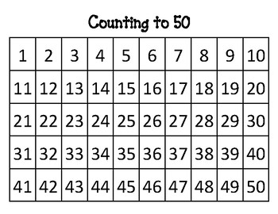50 Rectangle

Phonics Flash Cards

cat 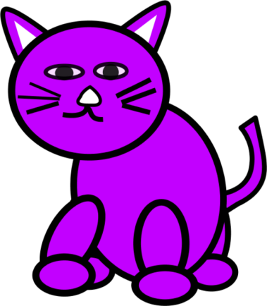

bin 

jet C:\Program Files\Off_2010\MEDIA\CAGCAT10\j0233070.wmf

hug 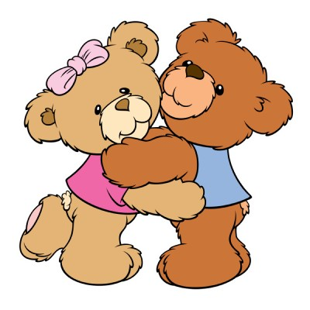

cot [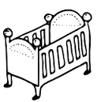](https://www.google.co.uk/imgres?imgurl=http://images.clipartpanda.com/cot-clipart-cot.png&imgrefurl=http://www.clipartpanda.com/categories/cot-20clipart&h=162&w=154&tbnid=qRoj4LG7zCT2ZM:&docid=1KjWaOJKJ2HG6M&hl=en&ei=98-pVviMIYTvUNCZqYgF&tbm=isch&ved=0ahUKEwi45MuMiszKAhWENxQKHdBMClEQMwglKAkwCQ)plant 

slide 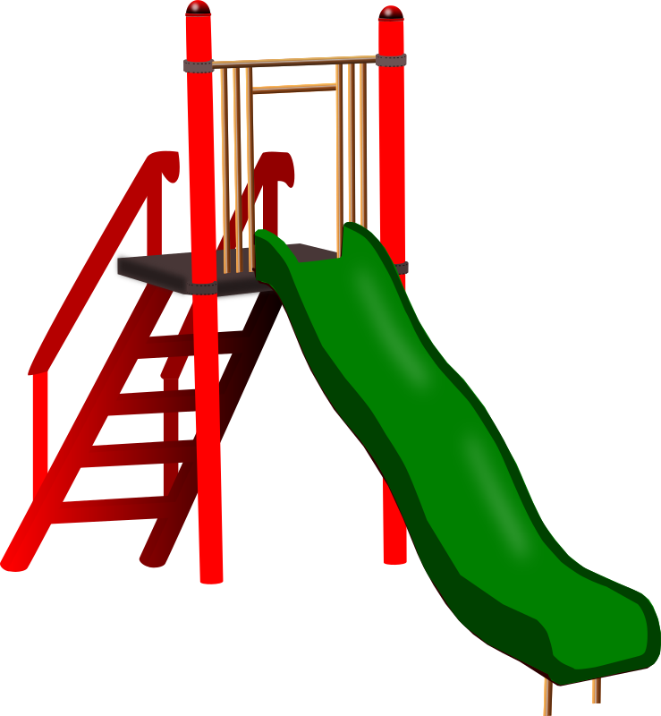

tree 

pram 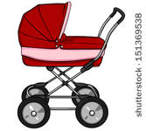

flag 

dracula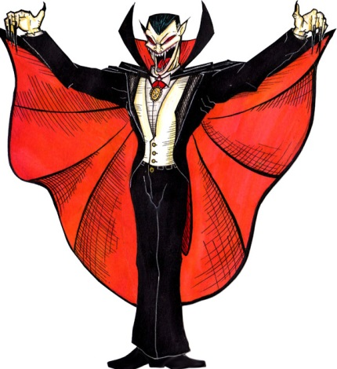grass

cloud C:\Program Files\Off_2010\MEDIA\CAGCAT10\j0293828.wmf

chick 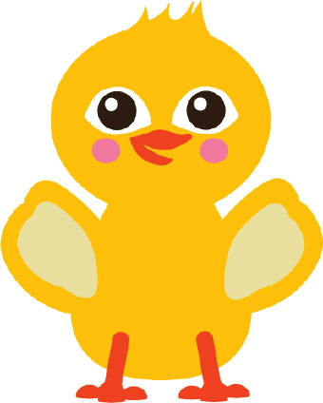

sheep 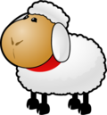

thirteen 

glass 

black 

broom 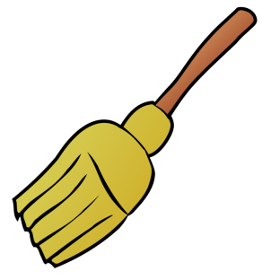

frog 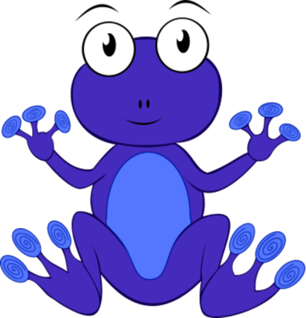

stick 

smile 

scooter 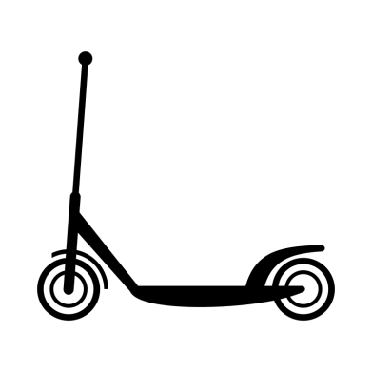

spoon 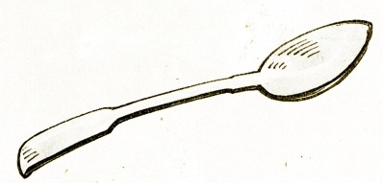

twins 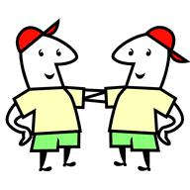

coin 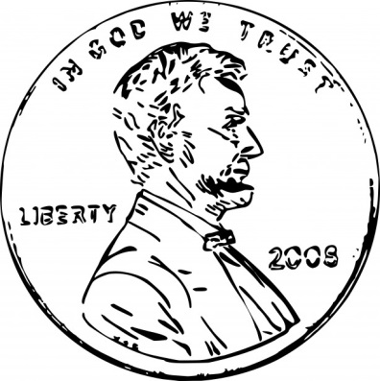

glue 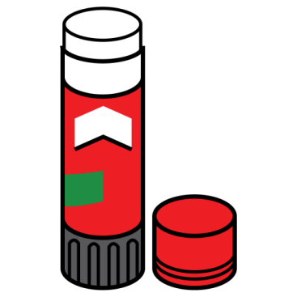

king 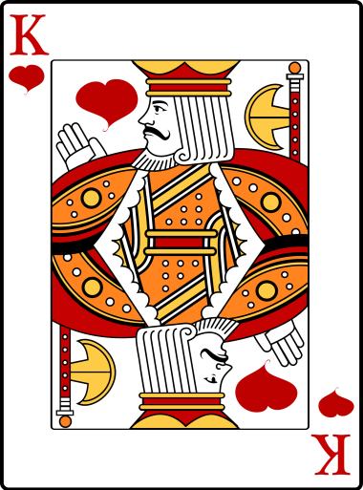

pulled 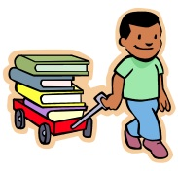

fang 

pound 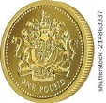

boat 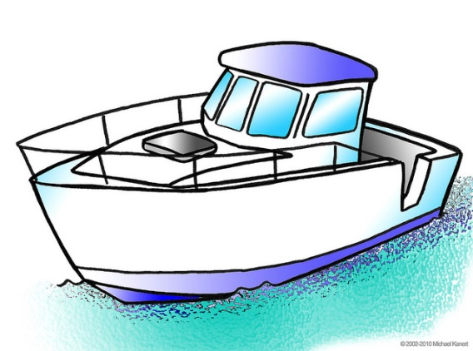

fork 

car C:\Program Files\Off_2010\MEDIA\CAGCAT10\j0212957.wmf

swim 

hill 

kiss 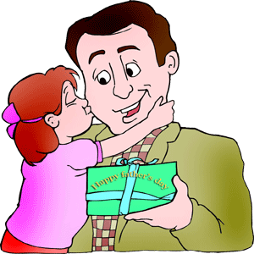

Buzz 

cliff 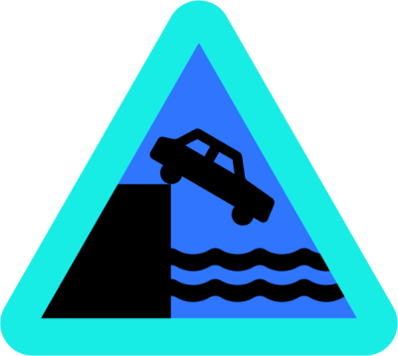

neck 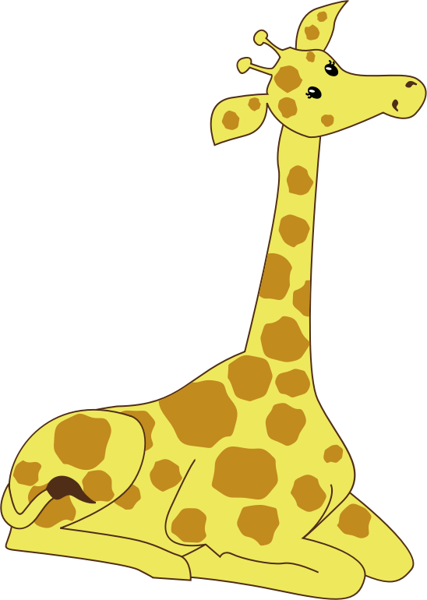

brush 

moth 

bee 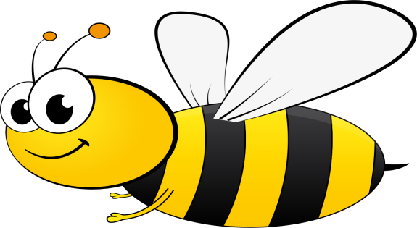

moon 

sand 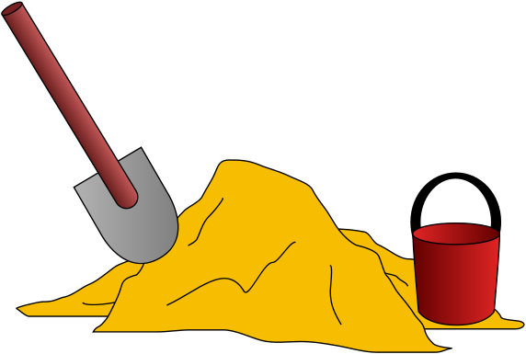

think 

**Free Educational Websites for Kids and Parents**

Numeracy and Literacy

* **Starfall-** Phonics, rhymes, reading and numeracy videos/activities.

<https://www.starfall.com/h/>

* **Fuel the Brain-** Numeracy and literacy games and free pintables. <https://www.fuelthebrain.com/>
* **Funbrain-**Online kid’s novels and games.

<https://www.funbrain.com/books>

* **Topmarks**– Numeracy games and mental maths starters (very good!).

[www.topmarks.co.uk](http://www.topmarks.co.uk)

* **Learning games for kids**- Games, videos and lessons. [https://www.learninggamesforkids.com](https://l.facebook.com/l.php?u=https%3A%2F%2Fwww.learninggamesforkids.com%2F%3Ffbclid%3DIwAR0T9nfBE4rl1Gg_FeFvZ7GQd6RvTKxg-xOmCcbIgrGuaaXCKMwTyKrWnJ0&h=AT2LDPVJLubfDbDVNKCIuezWSzvq30DEt3prc4oW0hsIKTG23bBY2V2YX8hzhn0309E4qprznLpoPNFu_nHkZIK9ZupMnM1O-aiSgFtfDXEnnwE6ng40CtucOEgcV4T5OzUG-6OmWr58dehju5WRQFePxUIalFACJWabplUR7NKZUex99qN2oiA5CE0HUKWDTsiPtWedXV1tLOT0Y3hO9zHAUdSDlzLRTcejXn8IP5kAgs8hqJKy3SlZ5YHS9eb7_vSwqF15rQf_suxgjx7FtuyY0rPrt-bD5e5T07pPXxcQh0MGWbLjDjPj47aFIPHwZD-4bbO7UwRvpo25lxMoMZAzF0XrMXPfpszhGEnE-jUfL9zeSI8oDRBDQjsM4m_hIkJvFLe1FiHLEWX2jo6hnuQyWtmzmgcOgRnf_joYQGKq79ubFJP_DQFr-7b3Fs0Y_N6l5hEpYN64U7FCyNOTMxmcS7vsw0bKAIsOWhF8C9OIjvTp2AsKjdvor6KGBUISW-cEs2OyieQr6yQmLlCO68yom-S5W0IwMVvqPqCc7ZEoRfL835t2Nuj6UJ0xgFdwS__wijz6CyRM0PaR0QraBSvyT-p8J2qfCdD-V9bhBf4m2yYX2HcTaWQt9DJ4yTMUUAA4Yfe0QZaR)
* **Vocabulary.co.il**- Phonics and spelling activities. [https://www.vocabulary.co.il](https://www.vocabulary.co.il/?fbclid=IwAR0njjVS8YV0UJ_BHbq104ChjDxgn_DILlFE8ImTgmgBXmEOwhx8bIixd6g)
* **ACB Ya**- Numeracy and literacy games. <https://www.abcya.com/grades/k>
* **Love my Books-** Activities based on specific books. <http://www.lovemybooks.co.uk/>
* **Phonics Play-** Free phonics username: march20 password: home. <https://www.phonicsplay.co.uk/>
* **Phonics Bloom-**Some free phonics games. <https://www.phonicsbloom.com/uk/game/list/phonics-games-phase-1>
* **Teach Your Monster to Read**- Reading and phonics games. <https://www.teachyourmonstertoread.com/>
* **Vooks**- Storybooks Brought to Life. <https://www.vooks.com/>
* **Oxford Owl-** ebooks and activities. <https://www.oxfordowl.co.uk/for-home/find-a-book/library-page/>

WAU

* **Make Me Genius-** Science videos. <https://www.makemegenius.com/>
* **National Geographic Kids-**WAU information, quizzes and games. <https://www.natgeokids.com/uk/>
* **Science Sparks-** Science experiments for kids. <https://www.science-sparks.com/>

ICT

* **Scratch/Scratch Jr-** Coding (Scratch Jr for iPad and Scratch for PC). <https://scratch.mit.edu/>

Mindfulness and Keeping Active

* **Cosmic Yoga-** Yoga videos for kids. <https://www.youtube.com/user/CosmicKidsYoga>
* **BBC Supermovers-** Learn numeracy and literacy through song and dance. <https://www.bbc.co.uk/teach/supermovers>
* **GoNoodle-** Brain breaks, dances and mindfulness videos. <https://www.gonoodle.com/>

Fun ideas for home

* **Highlights Kids-**Crafts, recipes, games and general knowledge/science articles. <https://www.highlightskids.com/>
* **Pinterest-** Home learning ideas. [https://www.pinterest.co.uk/search/pins/?rs=ac&len=2&q=home%20learning%20eyfs&eq=home%20learning&etslf=6240&term\_meta[]=home%7Cautocomplete%7C1&term\_meta[]=learning%7Cautocomplete%7C1&term\_meta[]=eyfs%7Cautocomplete%7C1](https://www.pinterest.co.uk/search/pins/?rs=ac&len=2&q=home%20learning%20eyfs&eq=home%20learning&etslf=6240&term_meta%5b%5d=home%7Cautocomplete%7C1&term_meta%5b%5d=learning%7Cautocomplete%7C1&term_meta%5b%5d=eyfs%7Cautocomplete%7C1)

Resources for Parents

* **Twinkl-** Endless resources for any age group and any subject- free for first month during school closures. Enter code UKTWINKLHELPS [www.twinkl.co.uk](http://www.twinkl.co.uk/?fbclid=IwAR0EZJP3I4tDRh2TAGSpW6FGuGgdUfYUBYK3sEWCHTRQroOYq9MMTbhXwZg)
* **TES-** Resources posted by other teachers (only a number are free). <https://www.tes.com/teaching-resources>
* **Primary Resources-** Lesson plans and resources for all areas of the curriculum. [www.primaryresources.co.uk](http://www.primaryresources.co.uk/?fbclid=IwAR2gjHw8L9G3tlyDmQ2OSNbruUxFT9c0zcdOOwYRByZRvcXnkQV_wtSd9mk)
* **BBC Teach Primary-** Lesson plans and resources for all curricular areas. <https://www.bbc.co.uk/teach/primary/zd7p47h>
* **Classroom Secrets-** Numeracy and literacy resource packs free during school closures. <https://classroomsecrets.co.uk/free-home-learning-packs/>
* **TTS-** Free learning activity booklets for all key stages. <https://www.tts-group.co.uk/home+learning+activities.html>
* **Empowering Little Minds-** Two free weeks of sensory play ideas. <https://www.empoweringlittleminds.co.uk/resources-1?fbclid=IwAR2UosfeiiaG4QnjiQVUbUnAO8WC0UHTUF0lx9sAJx1-Xy-1IynEwARWmUo>
* **Northern Ireland Curriculum-** <http://www.nicurriculum.org.uk/docs/key_stages_1_and_2/northern_ireland_curriculum_primary.pdf>

