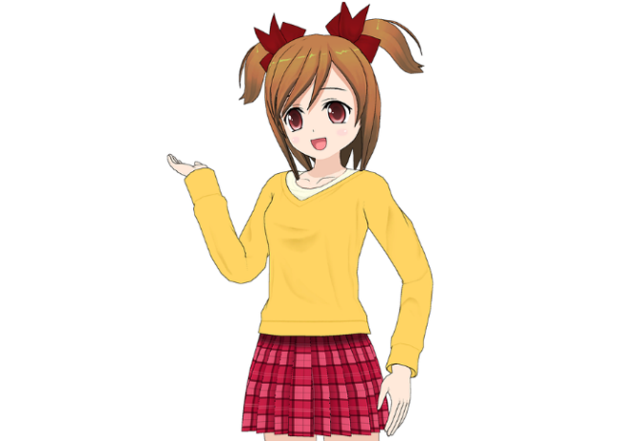
My Family Is Cool!
My family is cool,
This Photo by Unknown Author is licensed under CC BY
They’ll make you drool,
My Dad reads books,
This Photo by Unknown Author is licensed under CC BY-SA
My Mum has good looks,
My sister is a cool girl,
She’ll make you want to hurl,
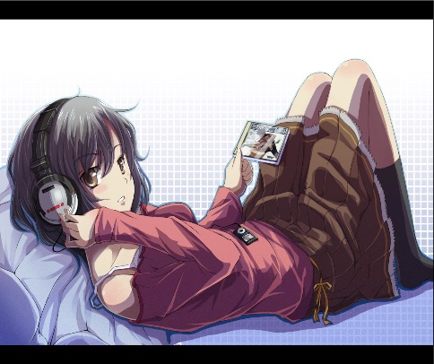
My brother is brave,
This Photo by Unknown Author is licensed under CC BY-NC-ND
I bet he has a cave,
FULL OF GOLDEN MEDALS!!!
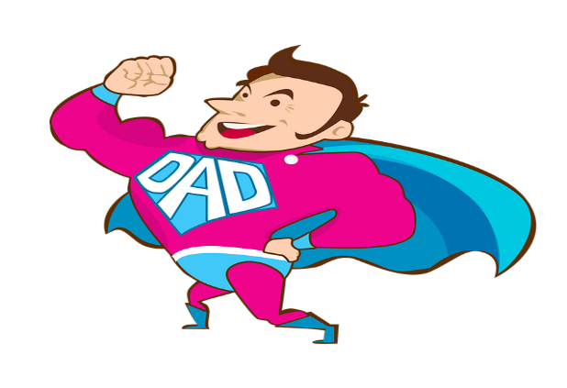
So yes, its lucky to be me,
Bet you don’t have a family,
AS COOL AS MINE!

