There was a little chicken that hung around with me. We did this, we did that he EVEN drunk tea with me!! One day I got hungry so guess where we went? The one and only McDonalds! It was cluck cluck’s favourite restaurant and mine too. The thing we didn’t know was that they had a new rule! They captured stray chicken! I tried to hide him but they were too smart they captured him cut him into pieces. That was the end of little cluck-cluck Maggar but the nuggets were delicious! So thank you cluck cluck friend.
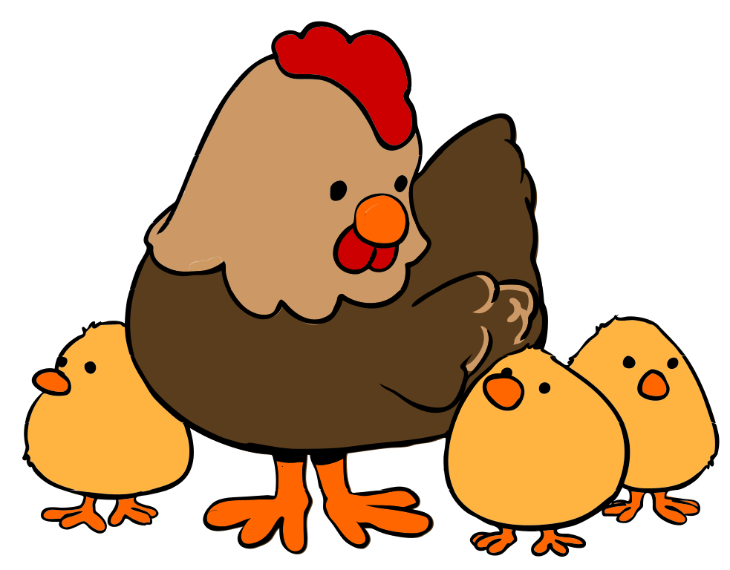

Chicken nuggets by Aisling

