Name: ______________________

**WALT: Write a Recount**

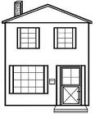

**First**

**Then**

**Finally**

