**School Council in Action**

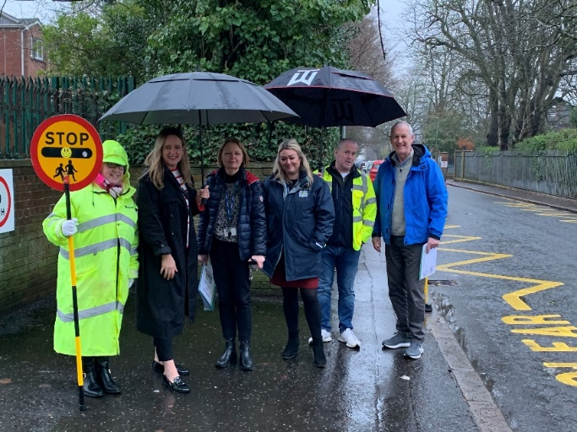

In Term 1 2023 the School Council wrote to local political representatives to raise concerns about the traffic conditions on Derryvolgie and Windsor Avenues particularly during drop off and collection times.

Drivers who constantly ignore the zig zag clearways at the gates and the single/double yellow lines put all in our school community’s safety at risk.

We know parking spaces are limited; this is true of all schools in urban areas. We are asking for people’s understanding and cooperation. The safety of our pupils is paramount. We are concerned that drivers may be involved in a serious accidents, so we are concerned for drivers’ safety and pupil safety.

Officials from DFER, PSNI, School SLT and Kate Nichol MLA met recently to try and find some solutions. Hopefully we will be able to make some progress soon.

We would like to thank Cllr. Gary Mc Keown and Claire Hanna MP for their input and time and help as well.

This is another example of the children’s voice in action through our school council. **You can make a difference!**