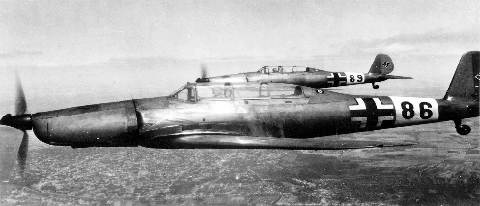
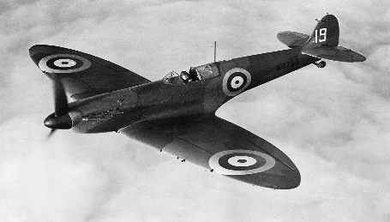
After The War
This Photo by Unknown Author is licensed under CC BY-SA
This Photo by Unknown Author is licensed under CC BY-SA

Author | Tom Palmer
Illustrator | Tom Palmer
Illustration | 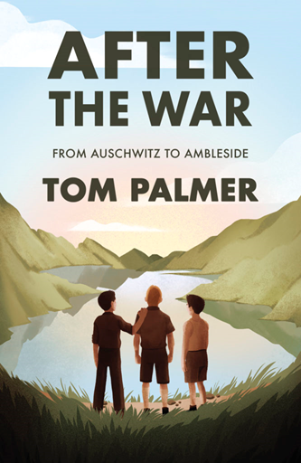

After The War is about three boys who were taken to concentration camp but our story starts when they are being taken to England after the war. They are moving to the Lake district. The boys names are Yossi, Leo and Mordecai. They are all fifteen years old and are being carried on a plane. Yossi was fascinated by planes. He should have been afraid of them as he had watched them bomb his homeland. But he loved how they could carry people from one place to another and not crash to the ground. As the boys reached England the plane rattled and Yossi was looking at the green fields and the lakes and it made him feel like he was going to his homeland.

