the rush times
Issue 1, April 18, 1912
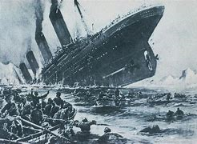 |  |  |  |  |  |  | The “Unsinkable” Titanic has Sunk  Previous reports have stated that all are safe but unfortunately, over 1500 men, women and children have lost their lives.
With all of the ship's safety measures, The RMS Titanic was thought to be unsinkable. Yet in the early hours of yesterday morning, in the North Atlantic Ocean, four days into the ship's maiden voyage from Southampton to New York City, the Titanic sank after colliding with an iceberg, tragically taking the lives of more than 1,500 passengers and crew.  RMS Titanic was the largest ship afloat and was owned and operated by the White Star Line and designed |  |  | by Thomas Andrews of Harland and Wolff.  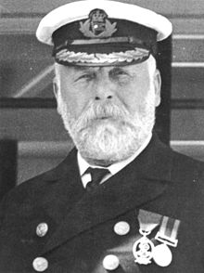  The Titanic was under the command of Capt. Edward Smith, who we believed, went down with the ship.  Early reports indicated that if Capt. Smith had slowed down the Titanic, it would not hit the iceberg. However, it is still too early to speculate. |  |  | It was reported that at around 2:20am the Carpathia received this distress signal from the Titanic: “Come at once. We have struck a berg. It's a CQD, old man.”  Unfortunately, the Carpathia was over 2 hours away. Just under two hours after Titanic sank, the Cunard liner RMS Carpathia arrived and brought aboard 705 survivors out of an estimated 2,229 passengers and crew.
Titanic Survivors
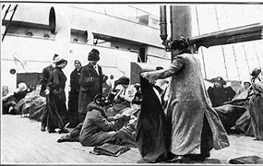
Survivors tending each other on board the rescued vessel Carpathia

Read more on P3
Eyewitness account on the sinking of The Titanic |  |  |  |  | 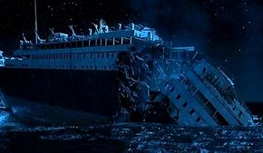  The search for responsibility began amid the grief of widows and orphans with accusations of ignored warnings, reckless attempts at record-setting and the woefully inadequate supply of lifeboats.  Stay tuned to The Rush Times as we unfold the story as it breaks.  Jaheim Rush reporting from The Docks, New York City.
Our reporter Jaheim Rush was at the docks in New York, when survivors of the sinking ship began arriving off the rescued vessel Carpathia.  Surviving passengers recount heart-breaking tales of parting with loved ones, watching the great ship sink while the steadfast band played "Nearer, My God, to Thee," and floating helplessly for long hours on icy seas. | Eyewitness report also stated that many passengers succumbed to hypothermia due to the freezing water of the Atlantic when they were forced to jump into the water due to the lack of lifeboats.

