The Water Cycle

The water cycle is a repeating process of evaporation, condensation, and precipitation. This happens every day.

Evaporation

Evaporation is when the sun heats up the surface of water. Some of the water gets turned into water vapour which goes to the cloud going on to condensation.

Condensation

When the air gets cooler the water vapour turns back into water droplets. The water drops form into clouds.

Precipitation

Water droplets in clouds attract other droplets and they grow bigger. When they are too big and heavy for the could they fall as rain, snow, hail and sleet.

Collection

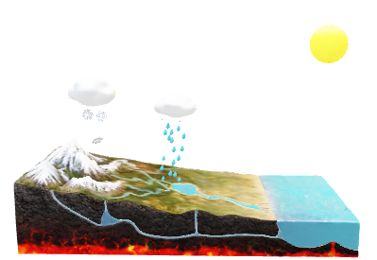When the water falls to the ground it can make streams or lakes and then it starts all over again.

Conclusion

If there was no water cycle, there would be endless drought. So that is why it is important to learn about the water cycle so we can stop droughts.