The Importance of Water
By Matthew Ferris
Water is made of 2 parts of the element hydrogen and 1 part of the element oxygen. It is also known as H20. It can be a solid such as ice, a liquid such as the water we drink or a gas such as steam when you boil water.
Where can you find water?
Water is everywhere!
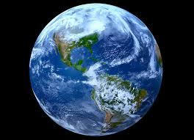
- Water covers ¾ of the earth in oceans and rivers
- Our bodies are made of 2/3 water
- Water is found in all food

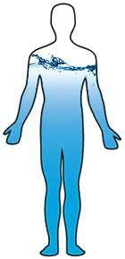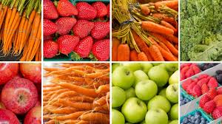

What is the water cycle?
The water cycle is how the earth’s water recycles itself.
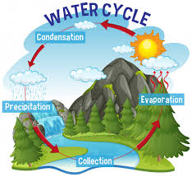
- First the sun heats the water molecules in rivers, lakes and the sea and turns the water into vapour that rises up into the air. This is called evaporation.
- Then condensation occurs and the water molecules turn into clouds
- When the air and water molecules cool down they turn into drops of water which fall to the earth as rain or if they are frozen they fall as snow. This is called precipitation.
- When water reaches the ground it flows across the land until it reaches the rivers and lakes or the sea. This is called collection.
- It can also sink into the ground because of gravity and reaches the water table that builds up underground.
Then all these steps repeat over and over again.
Why is water important?
- Water is one of the most important substances on earth.
- Without water there would be no life as all humans, plants and animals need water to live.
- Without water the earth would just be a rock planet with no life.
- That’s why we should look after our water and save it from pollution.

