Water
Water is an inorganic, transparent, tasteless, odourless, and nearly colourless chemical substance, which is the main constituent of Earth's hydrosphere and the fluids of most living organisms.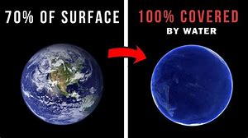
Earth Neptune

It is vital for all known forms of life, even though it provides no calories or organic nutrients.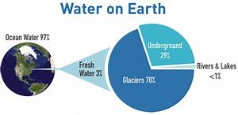
Its chemical formula is H2O, meaning that each of its molecules contains one oxygen and two hydrogen atoms, connected by covalent bonds.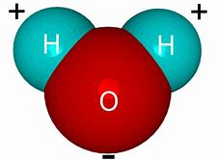
Did you know?

From a biological standpoint, water has many distinct properties that are critical for the proliferation of life?

