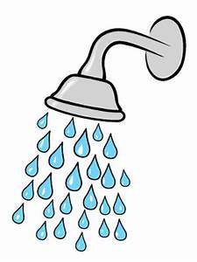
The Wonders of Water

About Water
Water is a liquid. It’s a very important liquid. Water is important in many ways let me tell you why. Water is everywhere.
Water Cycle
It starts when the water on earth evaporates (turns into gas) and goes in to the clouds until it gets cold and heavy and lets the water out. Sometimes the water is so cold it falls as snow, hail or sleet. The water falls and slides down mountains into lakes, the ocean or ponds than it all happens again this cycle is called the water cycle.
Salt Water
There is another type of water called saline water (salty water) In normal plain water many things do sink but in saline water most things float, this is because when there is salt in water it dissolves and makes the water denser which makes it heavier and makes many things that sinks in tap water float in salt water. It is a bad idea to drink salty water because you may dehydrate.
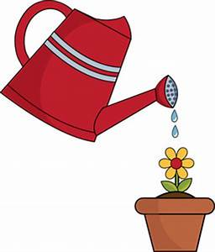
Why is Water Important
Water can be used in many ways like to keep us healthy, or to water our plants to keep them healthy, it can be used to keep us clean and to keep other objects clean as well. We should never waste water. Imagine a world without water nothing to keep us clean, all the flowers and crops will die, so many drinks won't be he same and the earth will be so dry. It really won't be the same without water.

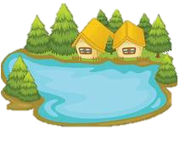
I hope this helps you to learn about water and why we should not waste it.

By Aqeelah
Water Cycle Diagram

By Aqeelah
Start here
The water turns into gas and goes up to the clouds.
And it repeats over and over again.
It forms water in the clouds.
It will fall and slide down the mountains into lakes, ponds and the sea.
The water will be to heavy and the cloud will let go and if its cold enough it will fall as snow, hail or sleek.

