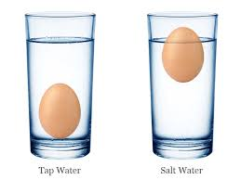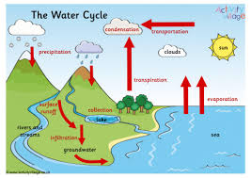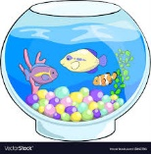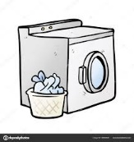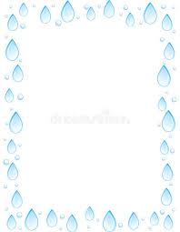

What is water useful for

Water is amazing. You can use it for many different things like to drink, to add to things you want to bake, to keep clean ,for fish to stay alive and to water your plants and cleans clothes See Water is very useful.

Water cycle

Water starts on earth it rises into the sky as a gas and goes into the clouds. Soon it will be to heavy inside the clouds and falls as rain and if it is cold enough it will fall as snow or hail. The rain will fall and slide the mountains and hills down to lakes, rivers and the ocean. Then after that it happens all again.

Saline Water

Saline water is also known as salt water. You shouldn’t drink salt water because you may dehydrate. In salt water more things float then in tap water this is because Saline water is denser then tap water and the salt in salt water makes it heavier and allows things to float