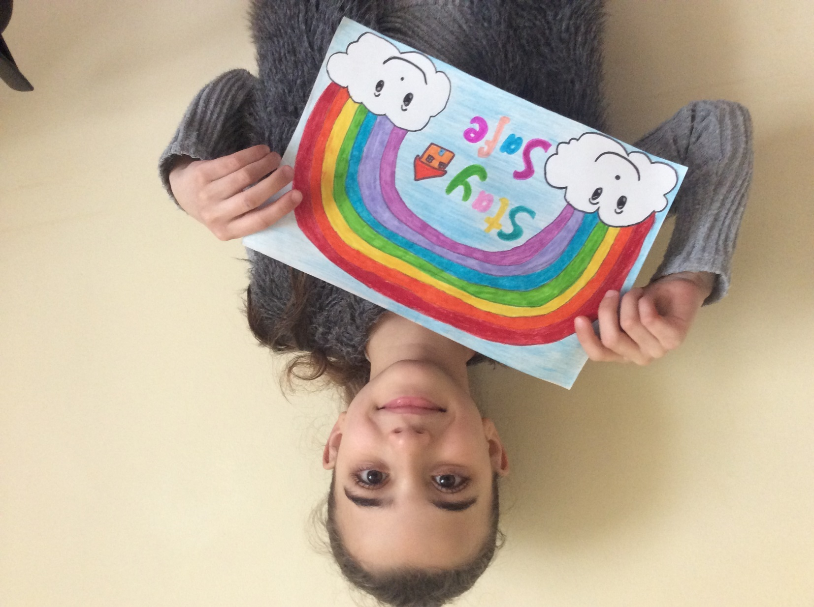
Rafeef’s fabulous Rainbow Poster P5K

