Staying Safe Around Water
Introduction
Water is an inorganic, transparent, tasteless, odourless, and nearly colourless chemical substance, which is the main constituent of Earth's hydrosphere and the fluids of most living organisms. It is vital for all known forms of life, even though it provides no calories or organic nutrients

Where do we find water?
- Rivers
- Lakes
- Baths
- Seas
- Ponds
- Seaside
- Swimming pool
- Water Park
- Puddles

How do we stay safe around water?
When out and about, near water, there is a special code that we must always follow
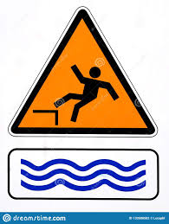
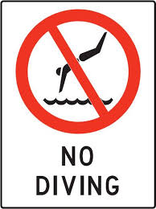
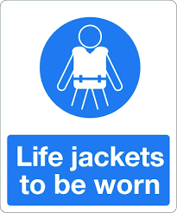
Stay
Away
From the
Edge
If you follow the special code, you will always be safe around water

Safety Flags
There are many different flags like;

The red flag meaning it is not safe

The red and yellow flag meaning you can only swim in between

The black and white flag meaning the area is not safe to swim in

Summary

Next time when you are near water, remember to keep to the signs and be very cautious.

STAY AWAY FROM THE EDGE
By Fatin Mohd Faisal

