The importance of water by Eabha O’Kane
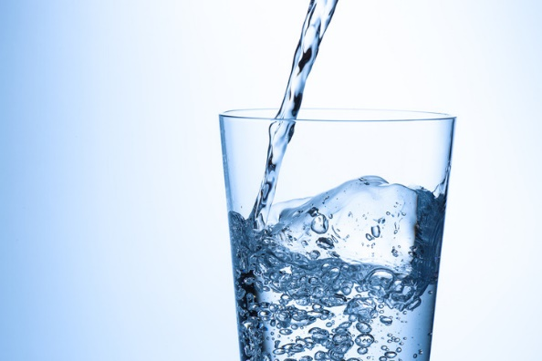
Introduction
All life on earth depends on water. It is made up of two elements, hydrogen and oxygen. Its chemical formula is H2O. Water is in all living things, whether they live at the bottom of the ocean or driest desert.

Where does water come from?
The ocean holds about 96.5% of the Earth’s water covering 70% of the world’s surface. Water can also be found in the atmosphere, lakes and rivers and non-seasonal frozen water such as the North Pole. Water can also exist underground in the water table.

The water cycle
Water is interesting because it can exist in 3 forms, liquid, gas or solid.
We obtain water via the water cycle. The water cycle involves water evaporating from the sea/ocean (turning into a gas), rising to the sky where it cools and condenses into tiny drops of water or ice crystals that we see as clouds and then falls as precipitation (rain or snow).
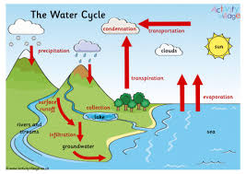

What is water useful for?
We need water to stay alive. Our bodies are approximately 70% made up of water. A person can live about a month without food but only 3 weeks without water.
Clean water is essential for cleaning ourselves and equipment that we need to use. Clean water can protect us from dangerous bacteria and viruses.
Water can also be used for cooking. Steaming and boiling food are well known cooking methods which need water.
Water is very important in agriculture. Plants and animals all need water to stay alive and they provide essential food sources for us.
Electricity can be formed through hydropower which harnesses water as a form of energy. Water is also needed as a coolant in nuclear power.
Water can also be fun. Water sports, swimming pools and paddling pools can be a great source of entertainment for people of all ages.

Water shortages
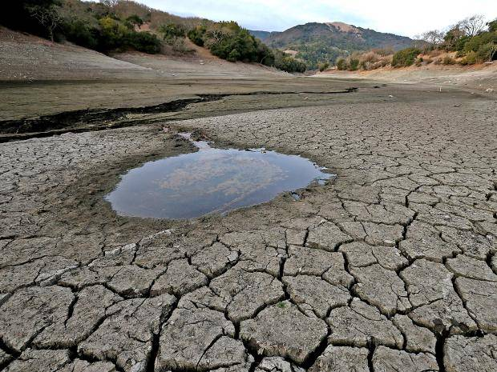
We have clean water provided to our homes by the water industry. Only 1 drop of water can contain millions of bacteria and viruses. And it could also have fish eggs, baby crabs, plankton, or even small worms. Also, water can contain different amount of salt depending on where it comes from. Water needs to be purified before we can use it, that happens at the sewage treatment plants.
Many places in the world don’t have access to clean water. This can be through drought or poverty. They may not be able to afford to clean the water to make it safe to drink or use. In those places water is often the cause of disease instead of protecting people from it.

We are running short of water because of the way we live our lives. Plastic waste is destroying our oceans and killing many of the creatures that depend on the oceans to live. Climate change is decreasing our water supply creating more droughts. Even flooding can mean less water available to use as the water is often dirty and carries disease.

Summary
As we can see water is essential to our planet and to us. So, it is our job to use it well and not to be wasteful. If we waste our water there might not be any left in the future.

