The Water Cycle by Emily Rafferty P5K

1.Introduction to the Water Cycle
The water cycle is the continuous movement of water all around the Earth. The water cycle is like a big circle and doesn’t really have a starting point. There are 4 main stages involved in the water cycle. These are: evaporation, condensation, precipitation and accumulation (or runoff). The main stages of the Water Cycle are shown in Figure 1.
Key fact 1: The water cycle is also known as the h2O Cycle or the hydrological cycle!
wikipidea
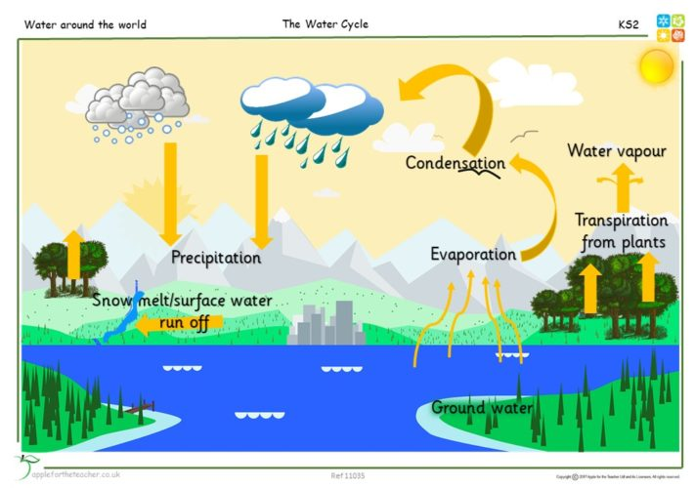
Figure 1: The Water Cycle (taken from www.applefortheteacher.com)

But where does all of the Earth’s water come from? Figure 2 provides information on this. Most of the Earth’s comes from Oceans. Much smaller amounts come from glaciers and the soil.

Key fact 3: 96.5% of the world is water!!! Much of the water we drink today has been around since the Jurassic time. only 2.5% of water is freshwater.
Key fact 2: TRANSPIRATION - this is the evaporation of water from plants. transpiration contributes to the evaporation cycle
wikipidea
2. Steps of the Water Cycle

  - Evaporation
Heat from the Sun causes water to evaporate from oceans, lakes and streams. Evaporation occurs when liquid water on Earth’s surface turns into water vapor in our atmosphere. Water from plants and trees also enters the atmosphere. This is called transpiration.

  - Condensation
Warm water vapor rises up through Earth’s atmosphere. As the water vapor rises higher and higher, the cool air of the atmosphere causes the water vapor to turn back into liquid water, creating clouds. This process is called condensation.

  - Precipitation
When a cloud becomes full of liquid water, it falls from the sky as rain or snow—also known as precipitation.

  - Accumulation
Accumulation is when the water in the different forms fall onto the ground and goes back into waterways or sinks into the ground. In water cycle process after the precipitation stage, the water returns back to Earth and goes back to the sea, ocean, rivers and other bodies of water. Then the process starts all over again.

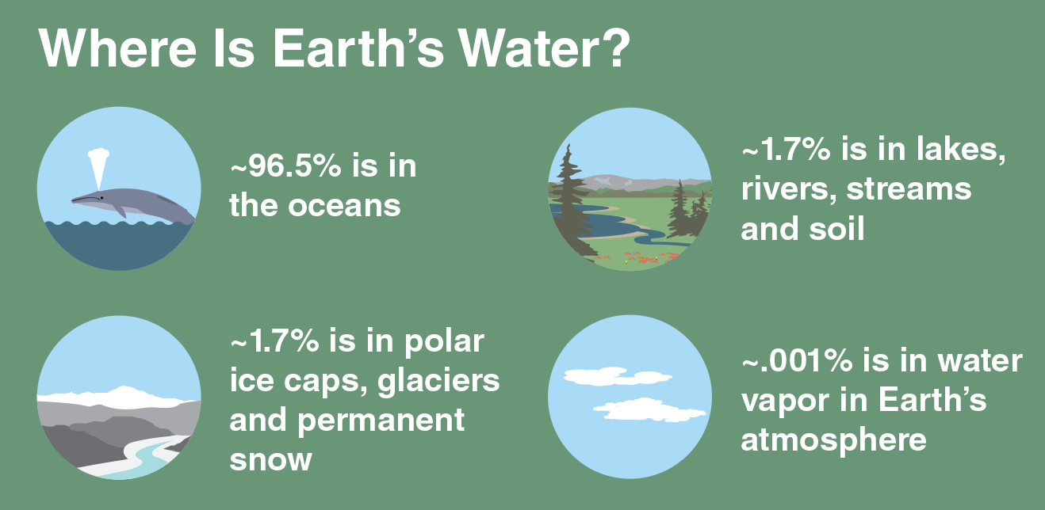
Figure 2: Where is Earths Water? (https://climatekids.nasa.gov/water-cycle/)

3. Why is the Water Cycle Important?
The water cycle is important because it ensures the availability of water for all living things. 95% of our world is water but most of it is either frozen or underground. The Water Cycle also helps to clean our water ready for us to use again!

4. Summary
The Water Cycle is 4 stage process which helps the Earth produce fresh water for all living things.
Key fact 4: All life is dependent upon water. Water makes up 60 to 70 percent of all living matter and humans cannot live without drinking water for more than a week. The water cycle, or hydrologic cycle, distributes fresh water all over the earth's surface.

