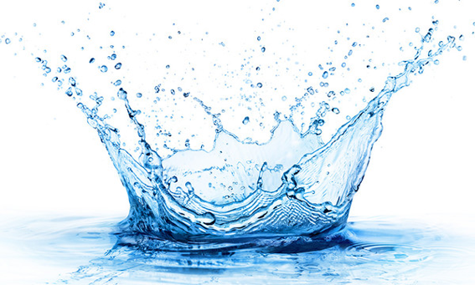
Why is water important?

Water is the source of life. Almost more than sixty percent of our bodies consists of water.If humans stop drinking water in a few days they die! That’s why water is very important. Without water life is impossible.
Mother Earth doesn’t want anyone to suffer! So that’s why it has lots and lots of water all around. About 71 percent of the Earth's surface is water-covered, and the oceans hold about 96.5 percent of all Earth's water. Water also exists in the air as water vapour.
Why is water important?

- Drinking
As we said, more than sixty percent of our bodies consists of water and most body organs need water to function. The blood itself mainly consists of water. We need to drink water every single day. Scientists say that we need eight cups of water a day. What will happen if we don’t drink enough water? If we don’t drink enough water we will get dehydrated and we will definitely have a lot of diseases.

- Showering
We need water to clean our bodies.
What will happen if we don’t shower for a year?
Firstly, there will be massive accumulation of bacteria and dead skin cells.Eventually, our outer skin layer will become so thick that we will develop a skin condition called Hyperkeratosis. And then one fine day Dandruff will have a party in our hair all day which will cause an extremely itchy head. Dirt, Pollutants and Bacteria will stick to the oil secreted by our skin which will make us look weird. Lastly Sebum will get accumulated to our skin and clog our skin pores, leading to inflammation of hair follicles and eventually resulting an acne. On the flip side, some experts believe that you don’t have to shower every day. One or two days a week is enough. It is to believe that too much showering might remove helpful organisms which actually protect us from harmful germs.

- Cleaning
Water is the cheapest cleaning material that is available for everyone. It can be used for washing up the dishes, mopping the floors, washing up the clothes, cleaning the cars, flushing a toilet and much much more!

4.Watering plants
Who doesn’t like the green nature? If you like to grow plants, don’t forget to water your plants and you can also use water for that too!

Summary
Water is life. We can’t survive without it. It’s essential for healthy life. Moreover, water is used for cleaning, showering and watering plants. We should save water for our the future generations.

