The water of our world
Everyone needs water including plants and animals. we need water to survive and hydrate. Nothing can live without it. Most of our body is water which I think is amazing. But, pollution is stopping some countries getting the energy and water they deserve.

Uses of water:
We need water for lots of things like cleaning, washing clothes, for hydration and , especially during lockdown, washing hands. we need it to stay alive, and our school and others are helping poor countries get water.

Water safety:
- we should never go in big currants in the sea or river.
- Never go into water if a lifeguard isn’t on duty.
- If there is a warning sign, never risk it.
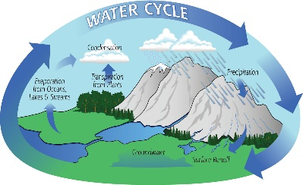
- Get a stick or a anything around you to see if it is deep.

- There might be broken glass, germs so on…
- It’s more important not to go in on a cold day.

What is water?
Water exists as molecules. Each molecule is made up of two hydrogen atoms joined to one oxygen atom. This means that the chemical formula is H₂0. Water is also ice that melts when at room temperature.

Importance of water:
We all need water for cold days and hot days. Because heating is water and you need lots of water on hot days. We need water to produce saliva so we can swallow properly and eat our food. If we didn’t have water we wouldn’t have meat because animals need water. Water is actually in our food! Our food doesn’t taste like water but that is how we mostly get water into our body. Water is amazing for keeping us clean too because we need water for baths, for showers and for hands.

Water pollution:
Littering is a terrible thing to do and no one should be doing it. But we are being so selfish because we are affecting other mammals in the sea and on land. our sea creatures shouldn’t have to suffer. Especially because they have nothing to do with it. In our oceans there are glass, plastic, metal, shopping trollies, batteries, burst sewage pipes I could go on forever. But right now, it’s the sea life soon, it will be us.
