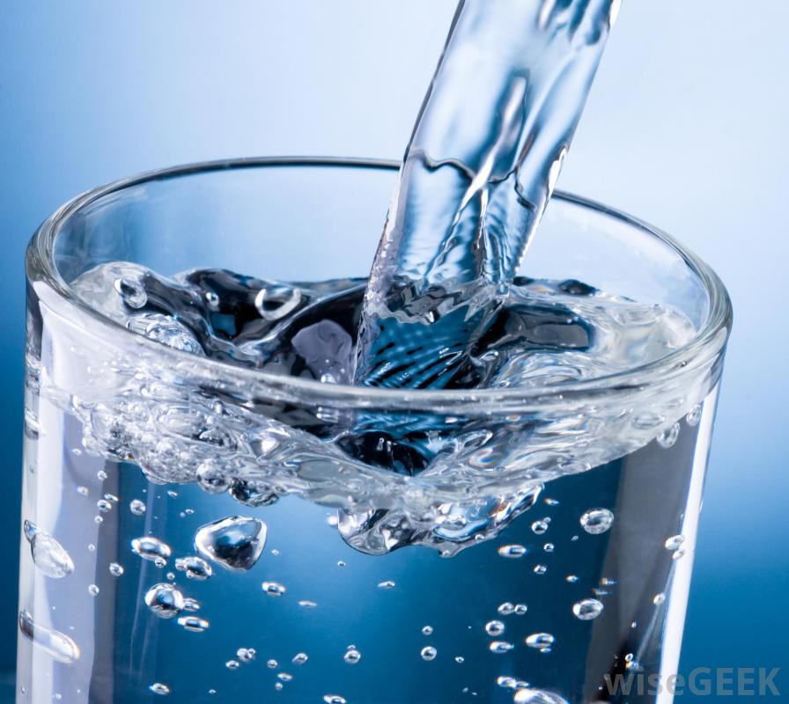
Student name: Shea Turley
Class name: P5K
Teacher name: Mrs. Kennedy
Date: 8th June 2020

the importance of Water
Table of Contents

water 2

Life Cycle of water 3

importance of water 4

Why is water so important? 4

Why its important for Humans 4

WHY ITS important for Agriculture 4

wHY ITS important at Home 5

Summary 6

glossary 7

water
Water is a colorless, transparent, odorless liquid that forms the seas, lakes, rivers, and rain and is the basis of the fluids of living organisms
It is life, nothing can live without it.
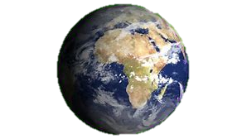
- 71% of the world is water, the other 29% is land
- Only 3% is drinkable water
- Water is unique in that it is the only natural substance that is found in all three physical states—liquid, solid, and gas—at the temperatures normally found on Earth.

- Water freezes at 0⁰c and boils at 100⁰c.

Life Cycle of water

importance of water

Why is water so important?
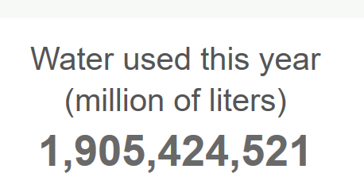

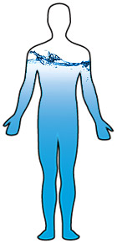
Why its important for Humans
We would die without it because:
- 60% of our bodies are water
- We need to drink water every day
- Humans can only live three days without water.
- It cleans diseases out of our bodies.
- 85% of the brain is made of water.
- it helps our digestive system

WHY ITS important for Agriculture
- Water is also used in agriculture to keep livestock clean and healthy, and to grow crops and produce.
- It is also used to apply pesticides and fertilizers
- It is used to cool crops and animals down when the weather gets too hot.
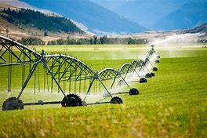

wHY ITS important at Home
Water is used in the home every day:
- Bathing to keep clean
- Washing our hands to keep germs away
- Flush the toilet
- And used to cook
- Outside its used for watering plants
- Washing the car
- Power hosing
- For fun, examples Water fights and Paddling pool
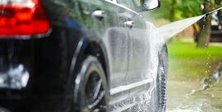
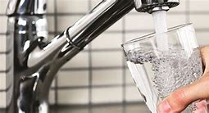

Summary

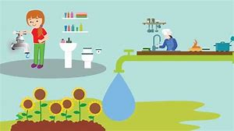
One day we may run out of water
- No water for drinking
- No water for cleaning
- No water for agriculture
Save Our Water!
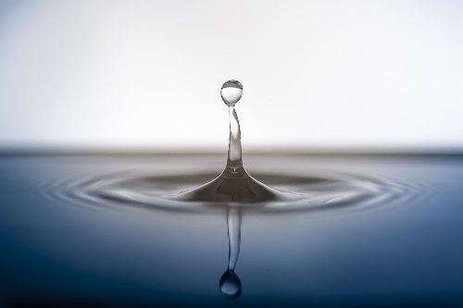

glossary
- ⁰c is a measurement of temperature in Celsius
- Celsius The Celsius scale, also known as the centigrade scale, is a temperature scale.
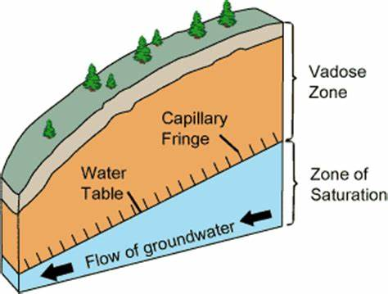
- infiltration is the diffusion or accumulation of foreign substances or in amounts in excess of the normal.

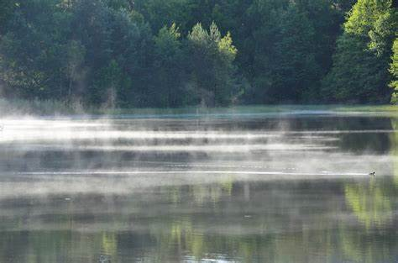
- evaporation the process of turning from liquid into vapor.

