Anna’s Maths Trail success
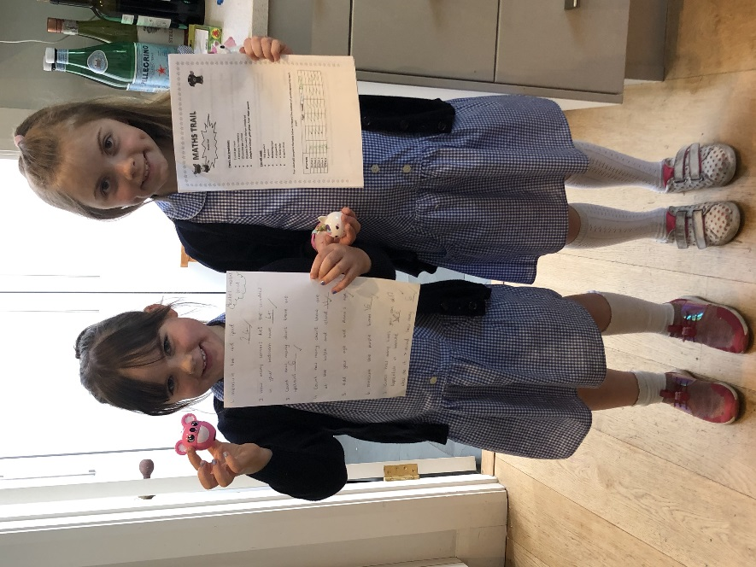
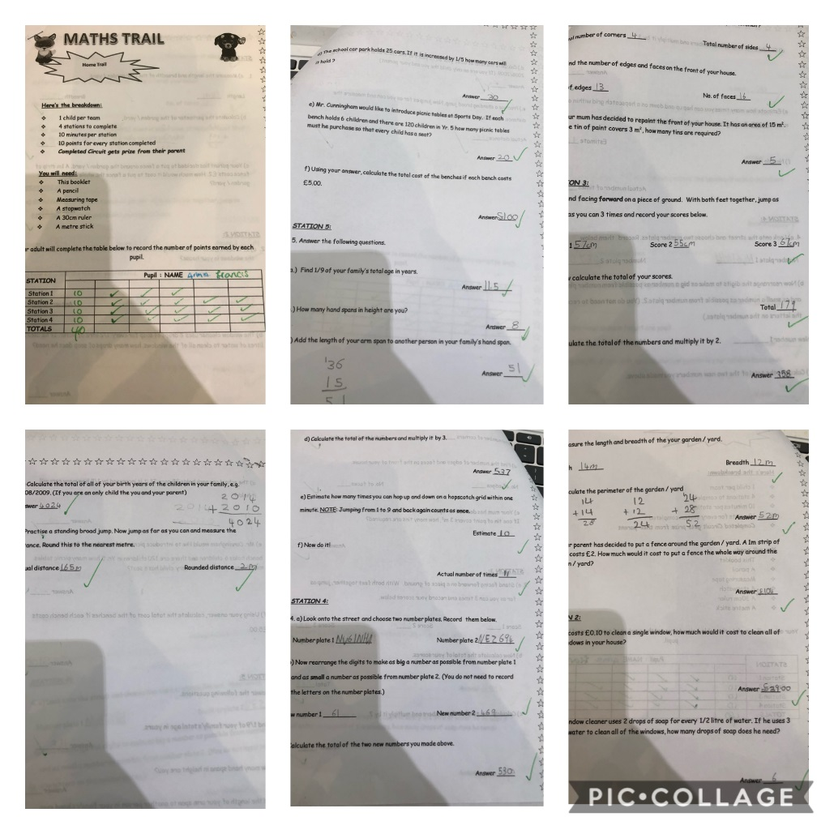
Anna from P5K has been working so hard on her Maths. (so has her little sis!) She recently completed the yr5 Maths Trail. Lots of measuring and working out completed, to find the solutions to all the problems set. Go Anna!!

