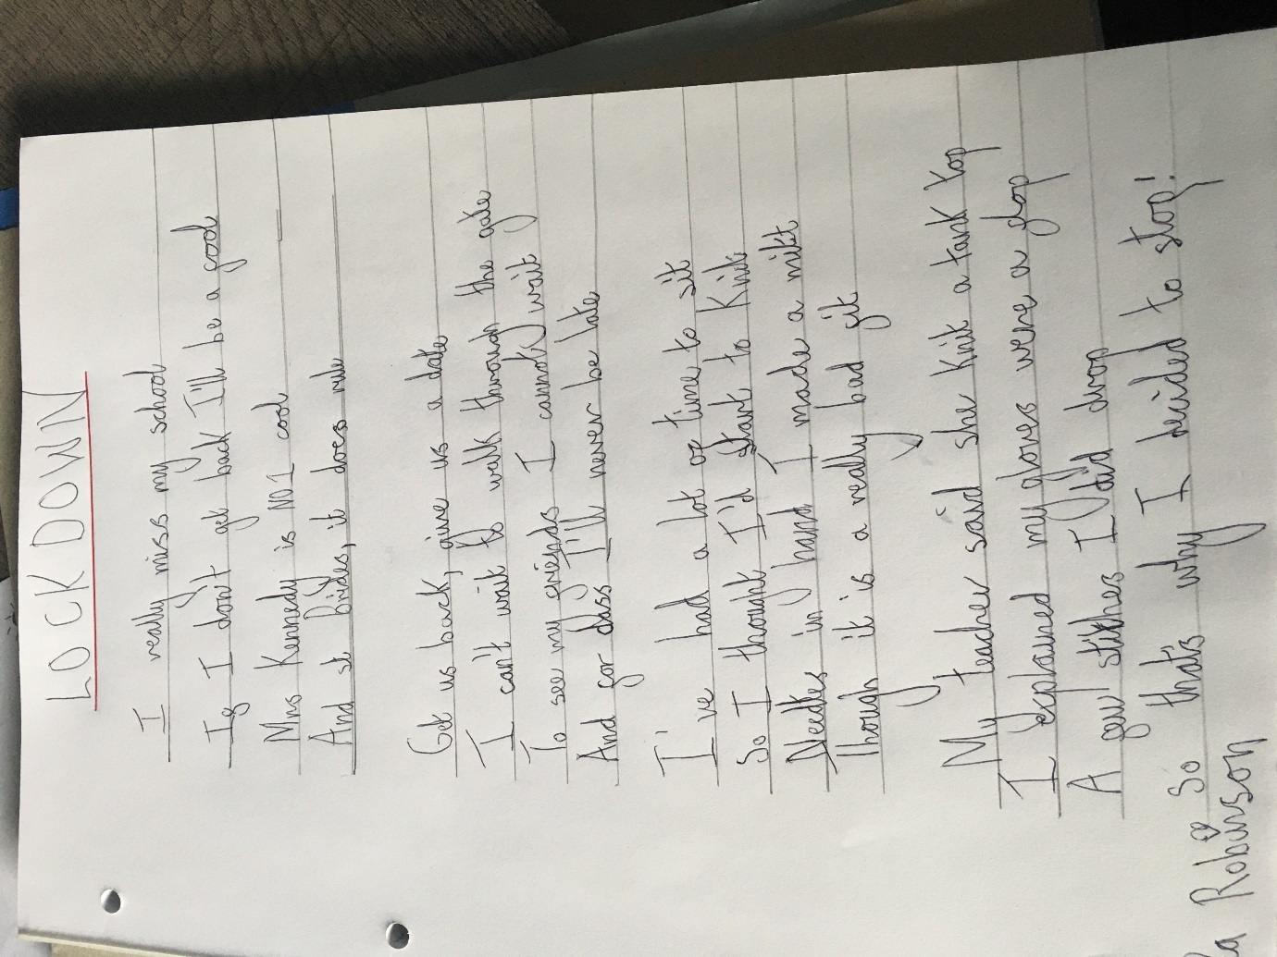
My poem on Lockdown
By
Tia P5K

