The Water Cycle
When the sun warms the water on the Earth’s surface it Evaporates, converting itself into water vapour and that’s when it begins its incredible journey flying into the sky, up towards the atmosphere. This stage of its journey is called Evaporation. When the water converts into vapour, it rises towards the atmosphere.Then, it cools down transforming itself into clouds. This second stage of its journey is called Condensation. Once the water has condensated and turned into a cloud, it continues its amazing journey by being blown by the wind travelling from one place to another. Clouds are actually tiny little drops of water suspended in the air, but when the clouds grow, they collect more and more water. These water drops then crash into each other and become bigger drops of water. Then at some point they’ll end up falling to the ground in the form of rain or even snow. This stage of the water cycle is called Precipitation. The water which falls to the ground which precipitates in the form of either rain or snow may land in rivers or even on the ground, to then seep through to subterranean currency of water. All this water must continue this long journey until it finally reaches the sea. When it arrives at the big blue sea it will once again begin the process.
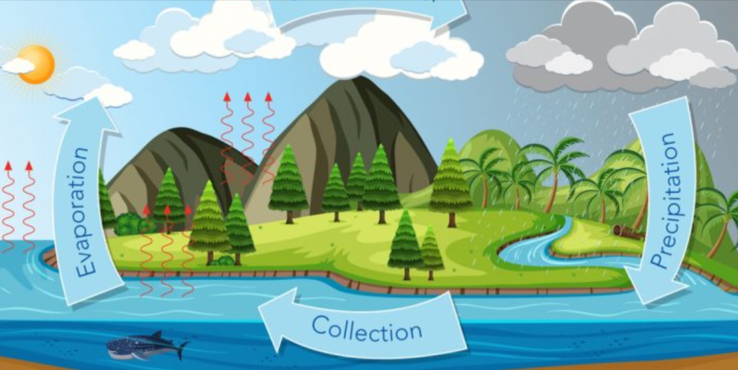
Evaporation, Condensation and Precipitation.
