* TITANTIC TIMELINE
* 1908-1912
* **By Chloe McQuillan**
* 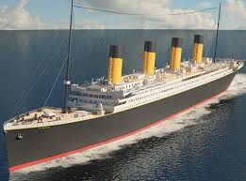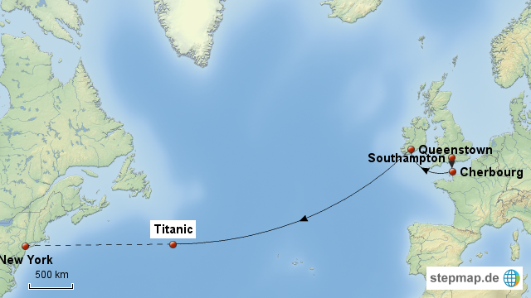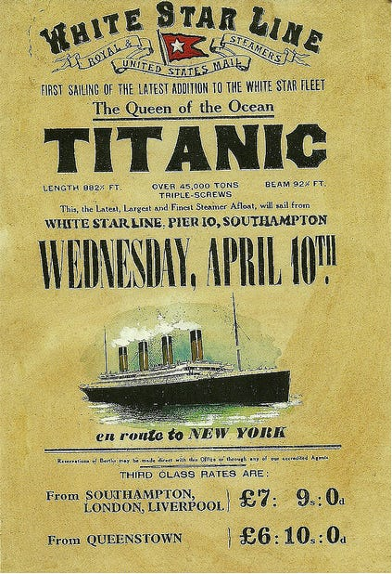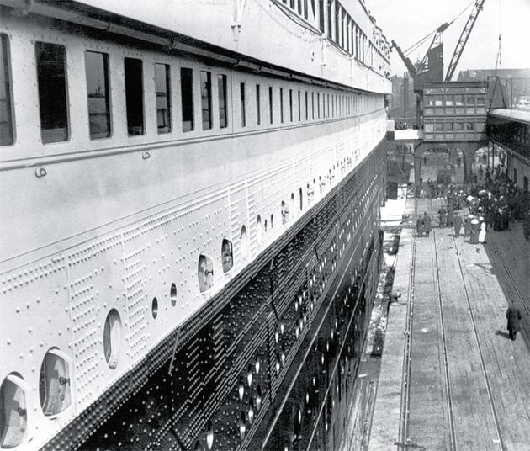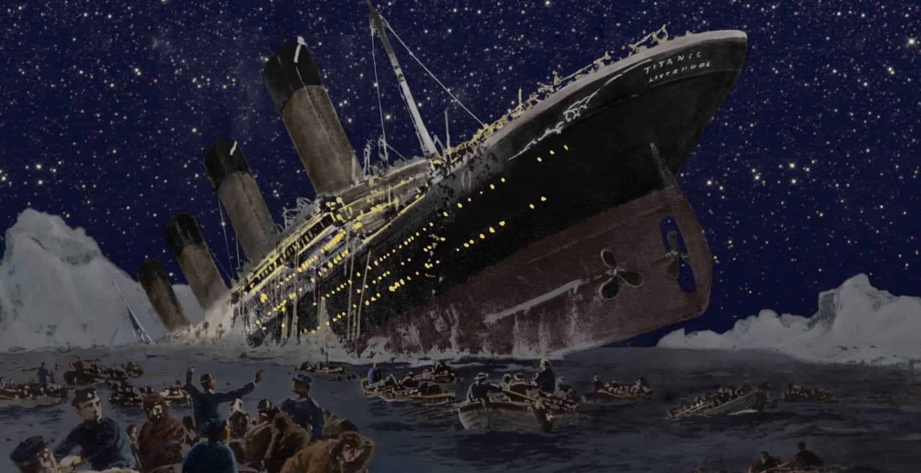

**29TH July 1908**

Thomas Andrew’s design was approved for the Titanic.

**31 March 1909**

Construction begins in Harland & Wolff shipyard Belfast

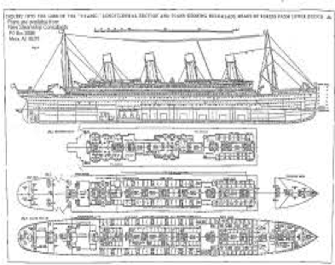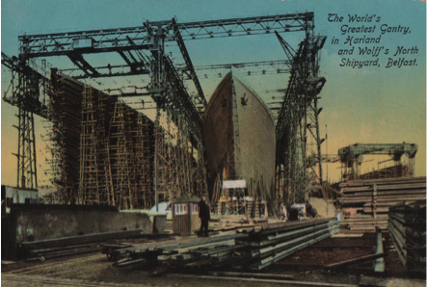

**31 May 1911**

The ship was launched into the River Lagan in the presence of 100,000 on lookers.

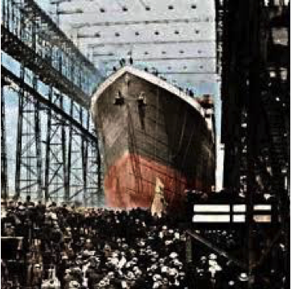

**April 11 1912**

Titanic reached Queenstown Ireland to pick up more passengers then set sail towards New York.

**10 April 1912**

Titanic begins its maiden voyage to New York with 2,220 passengers aboard.

**3rd April 1912**

Titanic arrives in Southampton – Liverpool.

**April 18 1912**

Despite the presence of icebergs the Carpathia traveled full speed to the passengers from the Titanic at 3:30 AM. The Titanic had sunk more than an hour earlier, but the Carpathia still saved 705 people who were in lifeboats.

**April 14 1912**

The Titanic collides with an iceberg in the North Atlantic at 11:40. It sends out a SOS signal to any nearby ships to come and save passengers and crew.

**April 15 1912**

After striking the iceberg, the Titanic slowly sinks into the North Atlantic Ocean about 400 miles away from Newfoundland Canada at 2.20 AM. Around over 1,500 people lose their lives.

* 