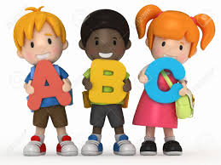

St Bride’s Assistants 2022-2023

Nursery | Kerri-Ann Barklie, Paula Boyle, Donna McVeigh,  Ruby Tindall, Hannah Nicholl
Primary One | Ella Fitzpatrick, Maxine McErlean, Shona McGuigan,  Louise McWilliams, IIfat Faisal, Anita O’Hare
Primary Two | Anna Marken, Jean Turner, Gráinne O’Neill, Aime Hennessy, Mossamat Shoraia, Emma Dolan, Chloe McBurney
Primary Three | Petra Biging, Rhianna Shaw, Shannon O’Neill,  Susan Guinnane, Emma Davidson, Helen Crawford,  Shebhan Rose-Egunjobi
Primary Four | Samaa Dabir, Celeste Forde, Alex Kelly, Vicky Turner
Primary Five | Emily Beattie, Emma Gorman, Karen McHugh, Marie Wright, Mary-May Holland
Primary Six | Catherine Cunnane, Grace McAlinden, Lucy O’Connor,  Lita Taylor, Dalal Alshaqaqi, Elizabeth Higgins
Primary Seven | Natasha O’Hare, Leah Leckey, Therese Mellon, Aber Wafdi, Anthony Quinn, Anne-Marie Brennan-Spiers, Amy Pearse

